TEACHER:MWALE CHI
KENNETH KAUNDA SECONDARY SCHOOL DESIGN AND TECHNOLOGY DEPARTMENT
LESSON PLAN

SUBJECT: DESIGN AND TECHNOLOGY CLASS:…… … DATE:……/……./20…. DURATION:………….
BOYS:…………………… GIRLS ………………………………………. TOTAL OF PUPILS… TOPIC: ANGLES SUBTOPIC: ANGLES
LEARNING OUTCOMES LSBAT
- Construct Angles using compass
RATIONALE
Knowledge: Construction of Angles 600, 900, 750, 300, 150, using compass
Skills: Accurate construction of Angles

Values: Awareness of methods of construction Angles
TEACHING AIDS
PART | LESSON CONTENT |  |  |  | METHODO LOGY | LEARNER ACTIVITY
Introduction | - Recap on the previous lesson |  |  |  | Questions and answers | Provide answers
Developme nt | ANGLES  - When two lines meet they form an angle.  - Angles are measured in degrees  TYPES OF ANGLES  - An acute angle is less than 90°;  - An obtuse angle is greater than 90° and less than 180°; a  - Reflex angle is greater than 180°.
Developme nt |  | TO CONSTRUCT AN ANGLE OF 45°  - Construct a right angle BAC (as on page 12).  - Bisect the right angle to obtain 45° angle | 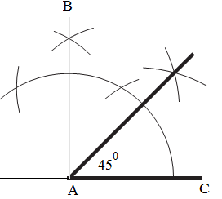
Developme nt |  | TO CONSTRUCT AN ANGLE OF 600  - Draw a line AB.  - Indicate point C anywhere on AB.  - With centre C and any convenient radius draw an arc to cut AB at D.  - With centre D and the same radius draw an arc to cut the previous one at E.  - Draw a line from C through E (line CF). FCB is the required 60°Angle | 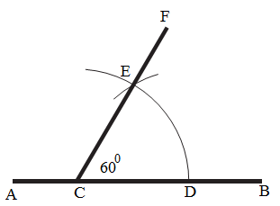
Developme nt |  | TO CONSTRUCT ANGLE OF 300  - Construct an angle of 600  - Bisect the 600angle  - Angle ABC is the required 300 angle | 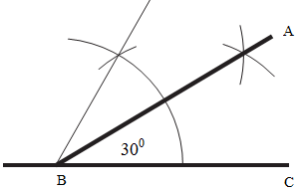
Application | CLASS EXERCISE  a. Construct the following angles 600, 900, 750, 300, 150, 165 67.5 |  |  |  | Q/A | Provide answers
Conclusion | - Recap on the main steps and points |  |  |  | V/E

LESSON EVALUATION

